LUXELANE CUSTOMER RETENTION ANALYSIS
1. Project Overview
Luxe Lane is a fictional e-commerce fashion business experiencing challenges with customer retention and repeat purchases.
This project analyzes customer behavior, complaints, delivery experience, returns, satisfaction and purchasing activity to understand why customers leave and which customers may require attention.
Tools: Excel, Power Query, PivotTables & Pivot Charts
Dataset: 2,508 records representing 2,500 unique customers.
2. Business Problem
Luxe Lane needed answers to four main questions:
- How many customers are being retained or lost?
- Which customer groups have higher churn?
- What problems are associated with customer churn?
- Which customers should the business prioritize for retention?
3. Dataset
The dataset contains customer-level information covering:
- Customer demographics
- Customer segment
- Acquisition channel
- Purchase behaviour
- Customer spending
- Complaints
- Returns and refunds
- Delivery performance
- Customer service
- Product and service ratings
- Satisfaction
- Pricing and competitor activity
- Churn and retention status
4. Data Cleaning
The raw dataset was cleaned before analysis.
Duplicate Records
The dataset contained 2,508 rows and 2,500 unique customers.
Duplicate records were identified and removed before the final analysis.
Missing Values
Missing values were checked across the dataset.
Fields such as complaint details, complaint satisfaction and churn dates contained blanks. These were reviewed based on their meaning rather than automatically replacing them with zero.
Data Types
Dates, numerical fields and categorical fields were checked and standardized to ensure they could be used correctly in calculations and PivotTables.
Category Consistency
Customer segments, complaint categories, churn reasons, acquisition channels and other categorical fields were checked for inconsistent entries.
5. Column Definitions
Column | Description
Customer_ID | Unique customer identifier
Age | Customer age
Gender | Customer gender
State | Customer location
Customer_Segment | Customer classification
Acquisition_Channel | Channel through which customer was acquired
Join_Date | Date customer joined LuxeLane
Tenure_Months | Length of customer relationship
Total_Orders | Total orders placed
Orders_Last_90_Days | Recent order activity
Total_Spend_NGN | Total customer spending
Spend_Last_90_Days_NGN | Recent customer spending
Average_Order_Value_NGN | Average amount spent per order
Days_Since_Last_Purchase | Days since last purchase
Most_Purchased_Category | Customer's main product category
Total_Complaints | Number of complaints
Primary_Complaint | Main complaint recorded
Complaint_Severity | Severity of complaint
Complaint_Status | Complaint resolution status
Days_To_Resolution | Time taken to resolve complaint
Number_of_Followups | Customer follow-ups
Escalated | Whether complaint was escalated
Complaint_Satisfaction | Satisfaction with complaint handling
Return_Count | Number of returns
Return_Rate | Percentage of purchases returned
Main_Return_Reason | Main reason for return
Refund_Delay_Days | Refund delay
Refund_Amount_NGN | Refund amount
Exchange_Requested | Whether customer requested exchange
Exchange_Successful | Whether exchange was completed
Average_Delivery_Days | Average delivery time
Expected_Delivery_Days | Expected delivery time
Delivery_Delay_Days | Delivery delay
Delivery_Delay_Count | Number of delayed deliveries
Damaged_Delivery_Count | Damaged deliveries
Missing_Item_Count | Missing items
Delivery_Satisfaction | Delivery rating
Support_Contacts | Number of support contacts
Average_Response_Time_Hours | Average support response time
Average_Resolution_Time_Hours | Average resolution time
First_Contact_Resolution | Whether issue was resolved at first contact
Customer_Service_Rating | Customer service rating
Product Rating | Product rating
Service_Rating | Service rating
Satisfaction_Score | Overall satisfaction
Trust Score | Customer trust score
NPS_Score | Likelihood of recommending Luxe Lane
Likelihood_To_Return | Likelihood of purchasing again
Average_Discount_Percent | Average discount received
Discount_Usage_Rate | Frequency of discount usage
Price_Increase_Experienced | Whether customer experienced price increase
Competitor_Purchase_Flag | Whether customer purchased from competitors
Competitor_Purchase_Frequency | Frequency of competitor purchases
Current Status | Retained, Churned, Dormant or At Risk
Retained | Retention indicator
Churned | Churn indicator
At_Risk | At-risk indicator
Dormant | Dormant customer indicator
Churn_Reason | Recorded reason for churn
Churn_Date | Date customer churned
Churn_Risk_Score | Customer churn-risk score

6. Analysis
The cleaned data was analyzed using Excel PivotTables and Pivot Charts.
The analysis focused on:
- Customer status
- Customer segment
- Acquisition channel
- Churn reasons
- Complaint patterns
- Days since last purchase
- Delivery delays
- Customer satisfaction
- Customer spending
- Customer risk
7. Key Findings
The dashboard shows:
- 2,500 customers
- 77.72% retention rate
- 22.28% churn rate
- 314 at-risk customers
- 418 dormant customers
The most frequently recorded churn reasons included:
- Issue Not Resolved
- Product Not as Described
- Discount Not Applied
Other recorded reasons included poor product quality, customer service problems, delivery issues, pricing and competitor activity.
The analysis also allows customer churn to be examined across different customer segments and acquisition channels.
8. Dashboard
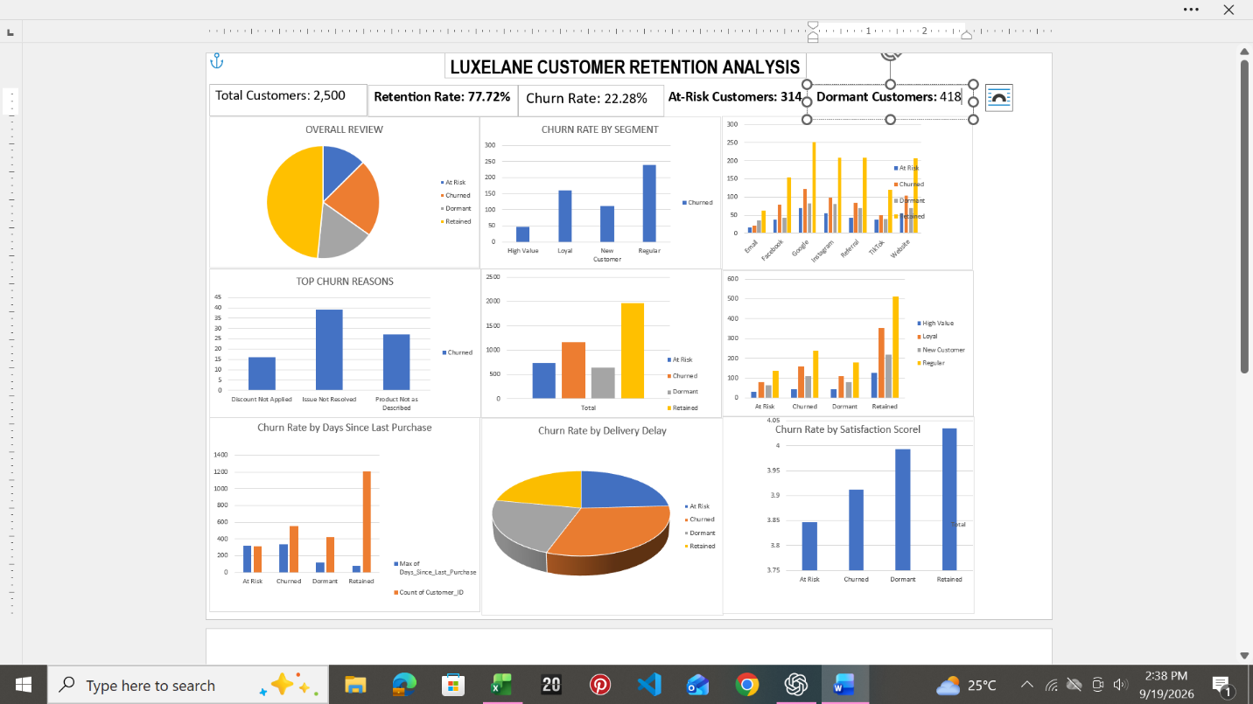
The final Excel dashboard provides a visual summary of:
Customer Retention
Overall customer status and retention performance.
Customer Segments
Comparison of churn across High Value, Loyal, New and Regular customers.
Churn Reasons
The main issues recorded among churned customers.
Customer Experience
Relationship between churn and factors such as delivery delays, satisfaction and purchasing activity.
Customer Risk
Identification of customers who are At Risk or Dormant.
9. Recommendations
Based on the analysis, Luxe Lane should:
- Improve complaint resolution and reduce unresolved customer issues.
- Monitor at-risk customers before they become churned customers.
- Investigate delivery problems and their effect on customer experience.
- Review product quality and product descriptions.
- Monitor high-value customers showing reduced purchasing activity.
- Track customer satisfaction and repeat-purchase behaviour regularly.
10. Conclusion
The analysis shows that customer retention is influenced by several parts of the customer experience, rather than one single issue.
By monitoring customer behaviour, complaints, delivery, satisfaction and churn indicators, Luxe Lane can identify customers requiring attention and make more informed retention decisions.

